**Predicting Four Drug Combination Cytotoxicity with Autonomous Robotic Platform Driven by an Active Learning Algorithm**

### Brittany Gomez, Eric Li, Matthew Mo

**Introduction**

Traditional drug discovery experiments have been bottle necked on a few accounts. Biological experiments are conventionally cumbersome, a scientist can contribute hours a day to wet lab work and months producing experimental results with reliable replication. On top of that, biology experiments are extremely costly. It is well known pharmaceutical companies spend hundreds of millions if not into the billions of dollars on just one marketable drug. The invention of robotic instruments to perform pipetting, and the use of active learning algorithms to help identify the most viable choices, reduce both the time and money needed to extract useful information.

In this experiment, automation and active learning are leveraged together to streamline possible drug combinations that could be useful against cancer cells. The experimental model is based on a combination matrix that can screen much larger amounts of drug concentrations never seen before.1 It is a high throughput method that explores over 20,000 different drug concentration combinations.

Three potential anti-cancer drugs were used in tandem with metformin. Griseofulvin, an antifungal agent, shown to induce G2/M cell cycle arrest and apoptosis in HeLa cells.2 Camptothecin is an anti-cancer drug known to cause apoptosis in HeLa cells, more specifically through caspases and serine proteases.3 Chloramphenicol, is a broad spectrum antibiotic shown to partially work through caspase apoptosis.4 Although metformin is non-toxic and is commonly used by a variety of people for dietary and health reasons, there is evidence that it can act synergistically with an anti-cancer drug.5

Active learning has been making waves recently with a slew of scientists using it.6 This has become the case due to it being able to deliver conclusions with less experiments, equaling less time and money. In this study, query-by-committee coupled with deep learning, Random Forest Regressor and Gaussian regression coupled with maximizing expected improvement (MEI) were explored in the simulation. Random Forest Regressor coupled with MEI was chosen to guide the experiment.

**Results**

**Simulations Dataset**

We are given a literature-derived1 research dataset (**Figure 1**) with a panel of 2 drugs as a proxy for our results. Simulation dataset consistent with our experimentation using the 4 drugs panel which totalled a 12 to the power 4 drug combination instances of roughly 21k data points was generated. We took the dataset and preprocessed by removing extreme values from the dataset. Furthermore, the dataset is reduced to sparser drug combinations of 6 of the combinations to accommodate run-time since active learning is very computationally intensive, resulting in 1296 data points (64). The dataset was pruned of data points with extreme values (outside of top 1% of standard deviation) and the ‘target’ cell viability has signs flipped such that it ranges from -1 to 0 instead of 0 - 1, which represents the proportion of cells alive after treatment. Therefore, in the flipped sign ‘target’, 0 denotes the most effective in killing while -1 denotes no cells are affected. Afterwards, the dataset is scaled using standard normalization with 𝝈=1. 10 instances from the dataset were randomly selected as initial training samples to allow the model to be more stable before the active query loop.

**Figure 1: (left)**  A 2-drug combination matrix from a previous research **(right)** Our simulated laboratory dataset with a 4-drug panel and their respective inverted cell viability from -1 to 0 with 0 being the most cell death.

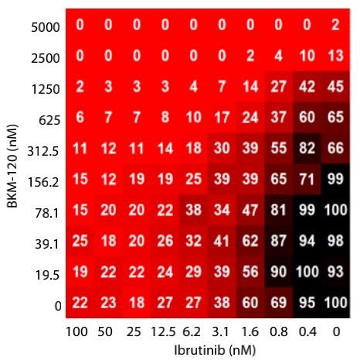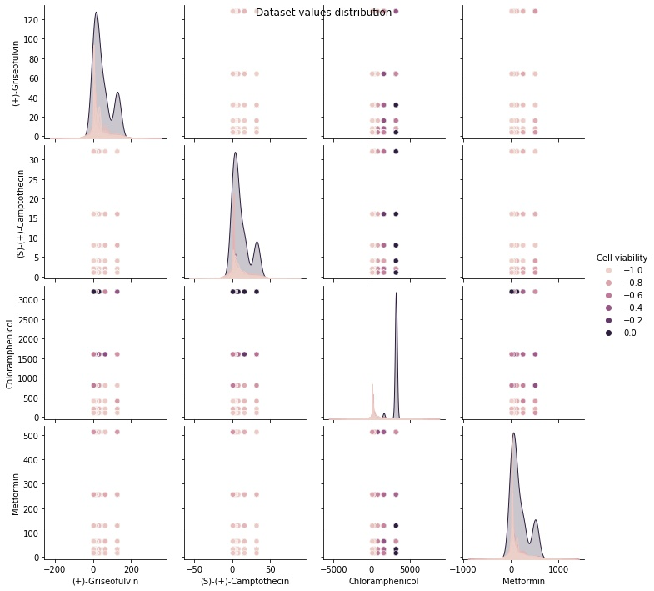

**Simulations**

In order to validate several prominent strategies in active learning, we performed both query-by-committee sampling and random sampling using a committee of 5 Neural Networks as estimator (each with same architecture and 2 hidden layers of 50 node); and Bayesian optimization for maximum expected improvement (MEI) with a Gaussian Process regressor and Random Forest Regressor. The results for both the literature research dataset and our generated datasets are shown in **Figure 2a & b**. Observing from the results, we chose Random Forest Regression as our base learner and MEI as our query method.

(a)

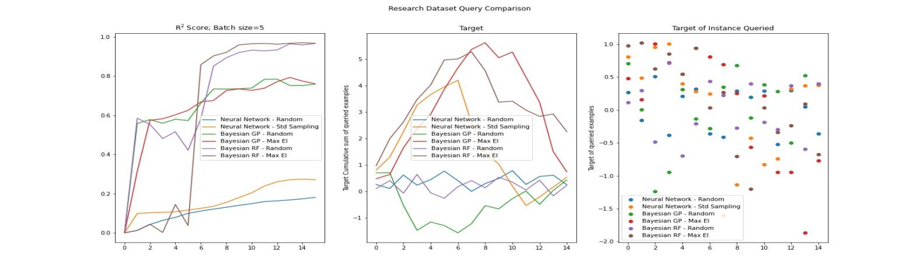

(b)

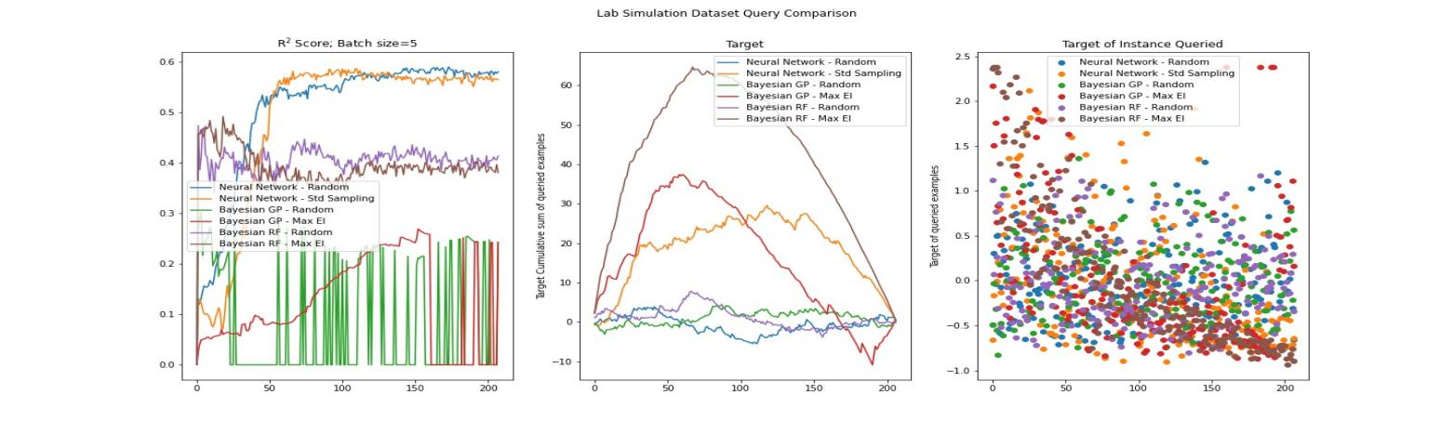

**Figure 2** Active learning of drugs combination between different active learners for a 2-drug panel derived from a research dataset based on literature (a) and our 4-drug panel simulated dataset (b). R2 score indicates the model performance on the test set. Target denotes negative of cell viability and x-axis denotes the query round number (batch size=5). Thus, higher the target, the better the performance of the corresponding drug combinations.

In the figures, we are able to see the rate of convergence onto both datasets as given by the regression score, and the cumulative target quantity showing the utility of points that maximize the amount of cell killing given by the particular drug combinations. Since the complexity of a 4-drug panel is higher and the amount of noise in the simulated dataset is expected to be higher, most of the models plateaued in regression score at around 0.4 to 0.6. Models such as Gaussian Process Regressor using Maximum Expected Improvement did not show a significant increase in model prediction score but still demonstrated high utility of points queried at the onset of training. The Gaussian process did not fit the dataset very well in general, which may have to do with an unoptimized length scale for prediction. Random Forest is able to fit to the data reasonably well and perform the queries that provide the highest experimental utility as marked by the peak of cumulative target quantity.

We also observed that while Random Forest and Gaussian Process are more capable than Neural Networks committee in finding maximum cell killing combinations. As shown in the more complex lab simulated dataset, it is generally a worse predictor of the actual value of the final cell viability, as given by the regression R2 score. The regression score for Random Forest Regressor peaked at around 0.4 while for NN committee it peaked at 0.6.

**Experiments**

According to what drugs are available in the lab and previous research, we identified 4 drugs to construct the experimental space and decide the concentration range to test. Their names, pharmacology, and experimental concentrations are described in **Table 1**.

**Table 1:** Four drugs used to construct combinations, their pharmacology, and experiment concentrations

|  |  |  |
| --- | --- | --- |
| **Drugs** | **Pharmacology** | **Concentrations (μM)** |
| (+)-Griseofulvin | Griseofulvin is used to treat skin infections, especially fungal infections. Yih-Huei Uen *et al.* reported that it can induce apoptosis in HL-60 cells.2 | 128, 64, 32, 16, 8, 4, 2, 1, 0.5, 0.25, 0.125, 0 |
| (S)-(+)-Camptothecin | Camptothecin is a topoisomerase inhibitor. It showed anticancer activity in preliminary clinical trials. T Shimizu *et al.* found that it can induce apoptosis in p53-null human leukemia HL60 cells.3 | 32, 16, 8, 4, 2, 1, 0.5, 0.25, 0.125, 0.0625, 0.03125, 0 |
| Chloramphenicol | Chloramphenicol is an antibiotic useful for the treatment of a number of bacterial infections. CT Kong *et al.* reported that it induce toxicity of human bone marrow and HL-60 cells.4 | 3200, 1600, 800, 400, 200, 100, 50 ,25, 12.5, 6.25, 3.125, 0 |
| Metformin | Metformin is an oral diabetes medicine that helps control blood sugar levels. Aycan Asik *et al. reported it* antileukemic effect when combined with paclitaxel.5 | 512, 256, 128, 64, 32, 16, 8, 4 ,2, 1, 0.5, 0 |

We used a Z-prime score to measure whether our positive control was truly effective. The four positive controls were 8 times the highest experimental concentration of the corresponding drug. The results are summarized in **Table 2**.

**Table 2:** Z-prime values for positive controls

|  |  |  |  |
| --- | --- | --- | --- |
| **(+)-Griseofulvin** | **(S)-(+)-Camptothecin** | **Chloramphenicol** | **Metformin** |
| 0.467 | 0.115 | 0.258 | -1.116 |

We can conclude that (+)-Griseofulvin had obvious effects against cancer cells; (S)-(+)-Camptothecin and Chloramphenicol had only moderate effects; Metformin did not have obvious cytotoxicity against cancer cells. However, there is a report that when Metformin is combined with other cancer drugs, it can enhance the anti-cancer effects.5

We carried out 2 rounds of experiments in total. The first round experiment was for initialization of the model and setting up the test set. Then the active learning model was trained on the initial data points (**Table 3**) and evaluated on the test set.

**Table 3**: First 5 rows of the first round training data

|  |  |  |  |  |
| --- | --- | --- | --- | --- |
| **X** | | | | **Y** |
| (+)-Griseofulvin | (S)-(+)-Camptothecin | Chloramphenicol | Metformin | Cell viability |
| 0.25 | 1.00 | 0.00 | 4.00 | 0.932 |
| 1.00 | 4.00 | 12.50 | 512.00 | 0.908 |
| 0.00 | 1.00 | 3200.00 | 1 | 0.849 |
| 16.00 | 8.00 | 50.00 | 64.00 | 0.783 |
| 16.00 | 32.00 | 200.00 | 1 | 0.722 |

Next, we used the model to query the next set of experiments with a batch size of 54. A constraint was put in place, that one concentration of one drug will not be queried more than 10 times, due to the limited volume of prepared treatment reagents. Finally, queried experiments were executed by CybioFelix and the Momentum automation platform in the next round. The model was retrained and evaluated on the test set again. For each round of experiments, we maintained a replicate number of 2. Cell Counting Kit-8 (CCK-8) assay was used to measure cell viability in each well. Workflow, plate design, and physical run Gantt chart are described in **Figure 4**.

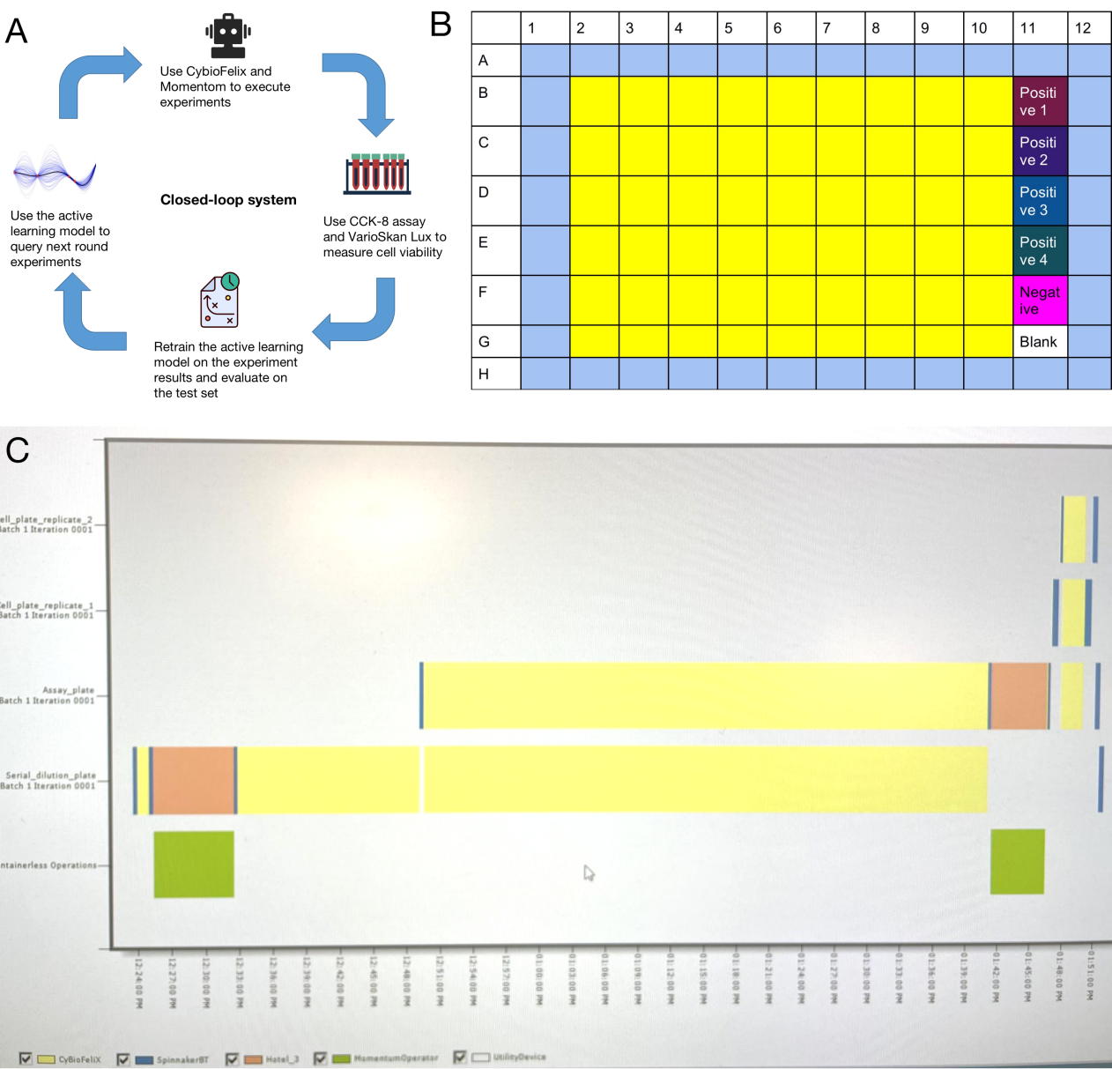

**Figure 4:** Experiment design. (A) The workflow of the closed-loop system. Each iteration contains 4 critical parts: model query experiments, autonomous robotic platform executes experiments, model fits the results again, and model queries the next round experiments. (B) Plate design. Bright yellow is the experimental zone. Cells are treated with different concentration combinations of 4 drugs in the experimental zone. Positive control well 1-4 contains experimental drugs with 8 times the highest experimental concentration of the corresponding drug. Negative control well only contains cell culture medium and cells. Blank well only contains cell culture medium. (C) Gantt chart of the physical run of the experiment. In our automation protocol we first carried out serial dilution and then, different drugs were transferred to target wells according to the queries. At last, the medium was dropped from the cell plates and treatments were added. Preparing treatment at CybioFelix took the longest time.

We measured our model’s performance on the test set in each experiment round. Firstly, we measured the error between model prediction and true test set values on well-scale. The results are summarized in **Figure 5**. We can conclude for those wells the model performed badly on the first round, the model performed much better after incorporating the data from the second round. We also checked the overall improvement by calculating MSE on a plate-scale. The MSE dropped from 0.0204 to 0.0195, which is a 4.5% accuracy improvement.

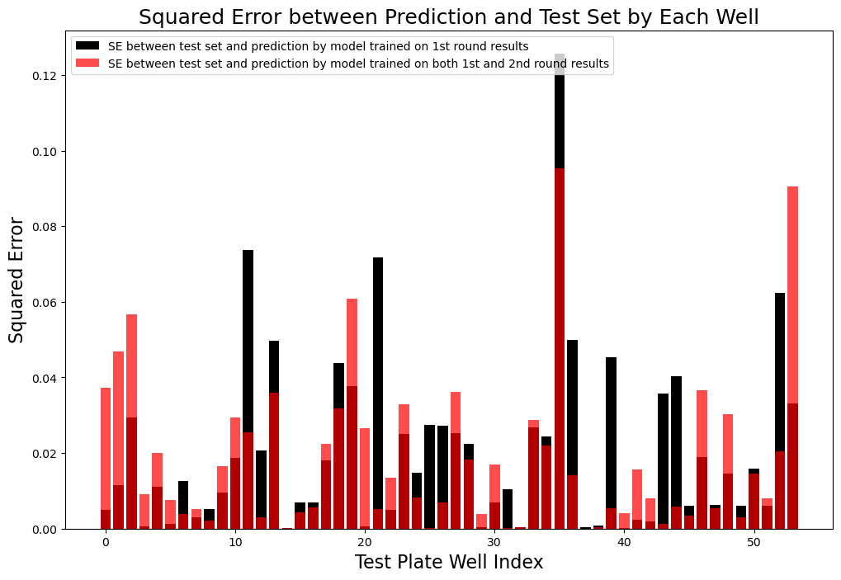

**Figure 5:** A comparison between the first round and the second round model accuracy on test set on well-scale

**Materials and methods**

**Cell culture**

Cancer cells were seeded in 96-well plates by CybioFelix platform 3 days before the experiment. Cells were incubated in Dulbecco’s Modified Eagle’s Medium (DMEM) with 10% fetal bovine serum (FBS, Gibico), 1% Penicillin-Streptomycin and incubated at 37 °C with 5% CO2.

**Drugs and reagents**

We started with the stock solutions, whose concentrations were 8-times of the highest experimental concentrations and used the CybioFelix platform to do serial dilution for different experiment concentrations.

**CCK-8 assay**

CCK-8 (GLPBIO) was employed to measure cell viability in each well. After the cells were incubated with the experimental drugs for 24 hours, 10μL CCK-8 kit was manually added to each well and then incubated for 1.5 hours in the cell incubator. Then, the Thermo Scientific Shaker was employed to make sure the dye was evenly distributed in each well (2 minutes). At last, the absorbance of each well was measured at 450nm by VarioSkan Lux. Then cell viability was measured as following:

(Eq. 1)

As = absorbance of the experimental well (absorbance of cells, medium, CCK8 and wells of the test drugs).

Ab = blank well absorbance (absorbance of wells containing medium and CCK8).

Ac = control well absorbance (absorbance of wells containing cells, medium and CCK8).

**Discussion**

We have demonstrated the utility of active learning over a relatively small drug combination experiment space that we have further confined from a combination of 4 drugs with 12 different concentrations. In real world scenarios, it is very likely that thousands to tens of thousands of compounds are to be tested in a high throughput manner. The vast experimental space in most biologically relevant experiments implicates the motivation of active learning in performing queries of high functional value early on in the experiment, since all forms of experimentation is a dramatic sub-sampling.

In our research, we have tested using a relatively basic uncertainty sampling technique that seeks to query points that estimators are most uncertain on and therefore minimize training loss in the quickest manner, using Bayesian optimization. In Bayesian optimization, instead of picking queries by maximizing the uncertainty of predictions, function values are evaluated at points where the probability of finding a higher value is large. The two query approaches have fundamental differences in the goal they prioritize to acquire via active selection. The first attempts to first maximize value to the estimator, while the latter the economic value to the experiment.

The functional value of each point is given by the acquisition function with Maximum Expected Improvement . In this case, we are going to use the expected improvement,

(Eq. 2)

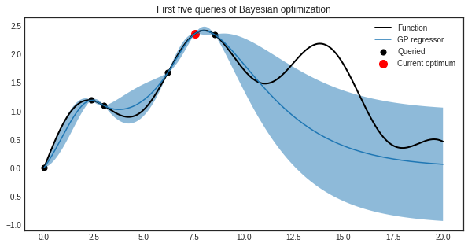

Figure 6: Optimization via Expected Improvements. Expected Improvements are measured across the proposed distribution of the discrepancy between the ground truth and the estimated value, and the query with the highest expected value is selected with priority (Source: ModAL documentation).

The acquired values as queried by the different models show marked differences in their priority. Notably, maximum expected improvement performed as expected and is highly efficient at finding drug combination instances with high cell killing ability shown by the increase of cumulative target quantity at the onset of query for both estimator models. Uncertainty sampling with the NN committee also exhibits some form of such behavior but it is unclear why, it could be due to the fact that extreme values in general cause cell death which is not apparent to the models as it is at the extreme boundary of the dataset.

Apart from the acquisition strategy, it is worth mentioning that estimator model selection is also extremely important in active learning, as well as the goal of the experiment. We can deduce that NN has a more complex behavior as given by the number parameters to be higher than a gaussian regression, which parameters scale with the number of given instances. However, a model with less parameters achieves a better utility maximization over a shorter time horizon.

To improve the experimental process, one of the most important things is to ensure that the cells are seeded evenly in each well. We observed that this was not the case during our experiment. Since our experiment is heavily dependent on cell density in each well, having an uneven density will cause errors in the results.

Moreover, since we did not have pre-experiment screenings to assess drug potency properly, all the positive controls did not have a strong potency. This led to difficulties when analyzing whether the drug combinations were effective.

In the future, if more time is allowed, we would test more drugs and have a wider concentration range.

**Reference**

1. Griner, Lesley A. Mathews, et al. "High-throughput combinatorial screening identifies drugs that cooperate with ibrutinib to kill activated B-cells–like diffuse large B-cell lymphoma cells." Proceedings of the National Academy of Sciences 111.6 (2014): 2349-2354.
2. Uen, Y. H., et al. "NF-kappaB pathway is involved in griseofulvin-induced G2/M arrest and apoptosis in HL-60 cells." Journal of Cellular Biochemistry 101.5 (2007): 1165-1175.
3. Shimizu, T., and Y. Pommier. "Camptothecin-induced apoptosis in p53-null human leukemia HL60 cells and their isolated nuclei: effects of the protease inhibitors Z-VAD-fmk and dichloroisocoumarin suggest an involvement of both caspases and serine proteases." Leukemia 11.8 (1997): 1238-1244.
4. Kong, C. T., et al. "Effects of antioxidants and a caspase inhibitor on chioramphenicol-induced toxicity of human bone marrow and HL-60 cells." Human & experimental toxicology 19.9 (2000): 503-510.
5. Asik, Aycan, et al. "Antileukemic effect of paclitaxel in combination with metformin in HL-60 cell line." Gene 647 (2018): 213-220.
6. Eisenstein, M. “Active machine learning helps drug hunters tackle biology.” Nat Biotechnol 38, 512–514 (2020).
7. B. Settles “Active Learning Literature Survey.” 2009.